PIRIMIPHOS-METHYL
239

ISO Common Name Pirimiphos-methyl
Chemical Name O-2-Diethylamino-6-methylpyrimidin-4-yl
O, O-dimethyl phosphorothioate(IUPAC);
methyl 2-[[[[[4,6-bis(difluoromethoxy)-2-pyrimidinyl]-mino]carbonyl]amino]sulfonyl]benzoate (CA; 29232-93-7)
Empirical formula C₁₁H₂₀N₃O₃PS
RMM. 305.3
b.p. decomposes on distillation
m.p. 5-18 ºC
v.p. 2.3 × 10⁻⁶ Pa at 20 °C
Solubility In water 10 mg/l, 20 °C (pH 7); miscible with most organic solvents, e.g. alcohols, ketones, halogenated hydrocarbons
Description Straw-coloured liquid
Stability Hydrolysed by concentrated acids and alkalis
Formulations Emulsifiable concentrates and capsule suspensions

PIRIMIPHOS-METHYL TECHNICAL
*239/TC/M/-

1 Sampling. Take at least 100 g.

2 Identity tests
2.1 Infrared. Prepare a film between sodium chloride plates and scan from 4000 to 650 cm⁻¹. The spectrum obtained from the sample should not differ significantly from that of the standard.
2.2 GLC. Use the capillary GC method below. The retention time of pirimiphos-methyl for the sample solution should not deviate by more than 2% from that of the calibration solution.

3 Pirimiphos-methyl

OUTLINE OF METHOD The sample of pirimiphos-methyl technical material is dissolved in acetone, containing an internal standard, and the pirimiphos-methyl content determined by capillary gas chromatography.

REAGENTS
Pirimiphos-methyl standard of known purity. Even purified standard of pirimiphos-methyl is not very stable at room temperature. It is important to keep the standard in a refrigerator. Before taking out standard from the bottle, it must be ensured that the temperature of the bottle has reached room temperature. Depending on the amount in the bottle this may take up to 4 hours. Accelerating this process by putting the bottle into a water bath with a temperature above 25°C is not recommended because this can cause degradation of the active substance.
Acetone
4,4'-Dimethoxybenzophenone internal standard. Must not contain impurities with the same retention time as pirimiphos-methyl.
Internal standard solution. Dissolve 0.20 g of 4,4'-dimethoxybenzophenone in acetone (100 ml). Prepare sufficient solution for the calibration solutions and the all samples to be analysed.
Calibration solution. Prepare calibration solutions in duplicate. Warm the material at 25 C, prior to weighing, to ensure it is completely liquid. Weigh (to the nearest 0.1 mg) 45 - 55 mg (s mg) of standard pirimiphos-methyl into a suitable flask or bottle (30 ml). Add by pipette or calibrated dispenser internal standard solution (10.0 ml). Cap the container and place it in an ultrasonic bath for 5 min to ensure complete solution (solutions C_{A} and C_{B}).

APPARATUS

Gas chromatograph equipped with split/splitless injection and a flame ionisation detector
Capillary column fused silica, 15 m × 0.25 (i.d.) mm coated with crosslinked dimethyl polysiloxane (DB-1 or equivalent); film thickness: 0.25 μm
Ultrasonic bath capable of producing 17 W/l. If a bath of lower power is used, the potential consequence is that extraction of the active ingredient in CS formulations could be incomplete and the result obtained could be significantly less than the actual content.
Electronic integrator or data system.

PROCEDURE

(a)Gas chromatographic conditions (typical):
Column Fused silica, 15 m × 0.25 mm (i. d.) coated with crosslinked dimethyl polysiloxane (DB-1 or equivalent); film thickness: 0.25 μm
Injection system

Injector split injection

Injection volume 1 μl

Split ratio 100:1
Detector flame ionisation
Temperatures

Injection port 170 ºC (Depending on the equipment used, an injection port temperature higher than 170°C may be used, but it has to be carefully considered and checked to avoid any degradation of pirimiphos-methyl in the injection system.)

Detector 310 ºC

Oven programme temp 1: 60 ºC, hold 0 min, ramp rate 25 ºC/min
temp 2: 100 ºC, hold 0 min, ramp rate 40 ºC/min
temp 3: 280 ºC, hold 1 min
Gas flow rates

Helium (carrier) 2 ml/min (typically 86 kPa at 60 °C); run at constant flow

Air 400 ml/min

Hydrogen 30 ml/min

Nitrogen (make up) to 30 ml/min
Retention times pirimiphos-methyl: about 4.8 min
internal standard: about 5.4 min

(b) System equilibration. Prepare two calibration solutions. Inject 1 μl portions of solution C_{A} until the response factors (f_{i}) obtained for two consecutive injections differ by less than 1.0%. Then inject a 1 μl portion of solution C_{B}. The response factor, f_{i}, for this solution should not deviate by more than 1.0% from that of solution C_{A}, otherwise prepare new calibration solutions. If the peak retention times differ significantly from the values given, then adjust the flow rate accordingly.

(c) Sample preparation. Prepare solutions in duplicate for each sample. Weigh (to the nearest 0.1 mg) sufficient sample to contain 45-55 mg (w mg) of pirimiphos-methyl into a suitable flask or bottle (30 ml). Add by pipette or calibrated dispenser the internal standard solution (10.0 ml). Cap the container and place it in an ultrasonic bath for 5 min (solutions S_{A} and S_{B}).

(d) Determination. Inject in duplicate 1 μl portions of each sample solution bracketing them with duplicate injections of the calibration solution as follows: calibration solution C_{A}, calibration solution C_{B,} calibration solution C_{A}, sample solution S1_{A}, sample solution S1_{B}, calibration solution C_{A}, sample solution S2_{A}, sample solution S2_{B}, calibration solution C_{A}, and so on for further samples. Measure the relevant peak areas. . If the peak shapes and precision of the analysis deteriorate, due to e.g. build-up of formulation residue in the GC, replace injection liners, gold seals and/or split vent lines

(e) Calculation. Calculate the mean value of each pair of response factors bracketing the two injections of a sample (f) and use this value for calculating the pirimiphos-methyl contents of the bracketed sample injections.

$f_{i}=\frac{I_{r}×s_{}×P_{}}{H_{s}}$
Content of pirimiphos-methyl $=\frac{{f×}_{}H_{w}}{I_{q}×w_{}}$ g/kg
where:
f_{i} = individual response factor
f = mean response factor
H_{s} = peak area of pirimiphos-methyl in the calibration solution
H_{w} = peak area of pirimiphos-methyl in the sample solution
I_{r} = peak area of the internal standard in the calibration solution
I_{q} = peak area of the internal standard in the sample solution
s = mass of the pirimiphos-methyl reference standard in the calibration
solution (mg)
w = mass of sample taken (mg)
P = purity of pirimiphos-methyl reference standard (g/kg)

Repeatability r = 8.6 to14 g/kg at 906 to 958 g/kg active ingredient content
Reproducibility R = 15 to 21 g/kg at 906 to 958 g/kg active ingredient
content

PIRIMIPHOS-METHYL EMULSIFIABLE CONCENTRATES
*239/EC/M/-

1 Sampling. Take at least 100g.

2 Identity tests
2.1 Infrared. As for technical 239/TC/M/2.2
2.2 GLC. As for technical 239/TC/M/2.2 and Fig 2.

3 Pirimiphos-methyl. As for pirimiphos-methyl technical 239/TC/M)/3.

Repeatability r = 7.2 g/kg at 490 g/kg active ingredient content
Reproducibility R = 16 g/kg at 490 g/kg active ingredient content

PIRIMIPHOS-METHYL CAPSULE SUSPENSIONS
*239/CS/M/-

1 Sampling. Take at least 100g.

2 Identity tests
2.1 Infrared. Extract a suitable portion of the sample with ethanol. Filter to remove any residue. Evaporate the solvent with a gentle stream of clean and dry air and proceed as for pirimiphos-methyl technical 239/TC/M/2.2
2.2 GLC.As for technical 239/TC/M/2.2 and Fig xx.

3 Pirimiphos-methyl. As for pirimiphos-methyl technical 239/TC/M/3 except add at:

APPARATUS

Sample filtering device with a membrane filtration unit compatible with organic solvents and with a 0.45 µm pore diameter

and change '(c) Sample preparation' to:
(c) Sample preparation. Prepare solutions in duplicate. Thoroughly homogenise the formulation, as received in the original sales pack, by inverting/shaking the bottle for 2 min or by using a mechanical stirrer. Do not decant a smaller sample or remove the test sample without thorough homogenisation. Weigh (to the nearest 0.1 mg) sufficient sample to contain 45-55 mg (w mg) of pirimiphos-methyl into a suitable flask or bottle (30 ml). Add 2 ml of water and cap the bottle then swirl well by hand to produce a uniform dispersion. Add by pipette or calibrated dispenser internal standard solution (10.0 ml). Cap the container and place it in an ultrasonic bath for 15 60 min. Note that placing large numbers of containers in the same bath simultaneously will reduce extraction efficiency considerably. Therefore no more than three containers should be treated at once. Filter the solutions through a 0.45 µm filter prior to analysis and discarding the first 1 ml (solutions S_{A} and S_{B}).

Repeatability r = 9.9 to 12 g/kg at 282 g/kg active ingredient content
Reproducibility R = 18 to 19 g/kg at 282 g/kg active ingredient content

4 Iso-pirimiphos-methyl. As for 239/CS TC/M/3 except:

OUTLINE OF METHOD Iso-pirimiphos-methyl (O-2-diethylamino-6-methylpyrimidin-4-yl O,S-dimethyl phosphorothioate) is determined along with pirimiphos-methyl, but due to the instability of iso-pirimiphos-methyl its content is calculated using the response factor of pirimiphos-methyl.

and add:

2.3 GLC-MS. Use the GC-MS method below (239/CS/M/3.5). The following peaks should appear prominently in the electron impact spectrum: 125.0 amu, 180.0 amu, 276.0 amu, 290.0 amu, and 305.0 amu (Fig. xx).

(a)Gas chromatographic conditions (typical):
Retention times pirimiphos-methyl: about 4.8 min
iso-pirimiphos-methyl: about 5.2 min
internal standard: about 5.4 min
Note: Ensure that any iso-pirimiphos-methyl peak is well separated from the pirimiphos-methyl peak. The retention time ratio of the two peaks should be at least:
$$\frac{t_{\text{iso}}}{t_{p}}=1\text{.}\text{06}±0\text{.}\text{02}$$
where:
t_{iso} = retention time of iso-pirimiphos-methyl
t_{p} = retention time of pirimiphos-methyl

and, in case of CS formulations, use in '(c) Sample preparation' the description provided in 239/CS/M/3, with the exception of the ultrasonic treatment: The time of the capped container in the ultrasonic bath should only be 15 minutes. Keeping the containers in the ultrasonic bath for 60 minutes may lead to substantial isomerisation between pirimiphos-methyl and iso-pirimiphos-methyl. However, this shorter ultrasonic treatment may be insufficient to fully extract the active substance as well as its isomer from the capsules. Therefore the content of both components in the sample solution must be determined using the chromatographic conditions described in CIPAC method 239a/TC/M/3. The final results for the iso- pirimiphos-methyl content are quoted relative to the active ingredient content in the same sample solutions.

and add:

(e) Calculation. Calculate the mean value of each pair of response factors of the pirimiphos-methyl calibration solutions bracketing the two injections of a sample, and use this value for calculating the iso-pirimiphos-methyl contents of the bracketed sample injections.

$f_{i}=\frac{I_{r}×s_{}×P_{}}{H_{s}}$
Content of iso-pirimiphos-methyl $=\frac{{f×}_{}H_{w}}{I_{q}×w_{}}$ g/kg

where:
f_{i} = individual response factor of pirimiphos-methyl
f = mean response factor of pirimiphos-methyl
H_{s} = peak area of pirimiphos-methyl in the calibration solution
H_{w} = peak area of iso-pirimiphos-methyl in the sample solution
I_{r} = peak area of the internal standard in the calibration solution
I_{q} = peak area of the internal standard in the sample solution
s = mass of the pirimiphos-methyl reference standard in the calibration solution (mg)
w = mass of sample taken (mg)
P = purity of pirimiphos-methyl reference standard (g/kg)

Repeatability r = .. g/kg at … g/kg active ingredient content
Reproducibility R = .. g/kg at … g/kg active ingredient content

5 Other relevant impurities

O,O-dimethyl phosphorochloridothioate (DMPCT)
O,O,O-trimethyl phosphorothioate (MeOOOPS)
O,O,S-trimethyl phosphorothioate (MeOOSPO)
O,O,S-trimethyl phosphorodithioate (MeOOSPS)

OUTLINE OF METHOD DMPCT MeOOOPS, MeOOSPO and MeOOSPS are determined relative to the active ingredient by capillary gas chromatography-mass spectrometry with 4,4-dimethoxybenzophenone as internal standard, applying the standard addition mode.
Note: The standard addition mode is used because the intensity of the detector signal depends markedly on the presence of other formulation components.

5.1 Determination of DMPCT, MeOOOPS, MeOOSPO and MeOOSPS

REAGENTS

Reference standards, of known purity, of DMPCT, MeOOOPS, MeOOSPO and MeOOSPS. Even purified standards of these compounds are not very stable at room temperature. It is important to keep them in a refrigerator. Before taking out standard from the bottle, it must be ensured that the temperature of the bottle has reached room temperature. Depending on the amount in the bottle this may take up to 4 hours.
Acetone glass distilled grade
4,4'-Dimethoxybenzophenone internal standard. Must not contain impurities with the same retention time as the relevant impurities of pirimiphos-methyl
Internal standard solution. Dissolve 20 mg of 4,4'-dimethoxybenzophenone in acetone (10.0 ml). Dilute 5.0 ml of this stock solution with acetone to 500.0 ml..
Reference standard stock solution. Prepare a single reference standard stock solution. Weigh (to the nearest 0.1 mg) 80 - 90 mg (s mg) of each reference standard into the same volumetric flask (100 ml). Add internal standard solution (about 90 ml) and place the flask in an ultrasonic bath for 5 min. Allow to cool and make up to the mark with internal standard solution (reference standard stock solution, solution C_{A}). Transfer by pipette 10.0 ml of solution C_{A} into a volumetric flask (100 ml) and make up to volume with internal standard solution. Mix thoroughly (reference standard working solution, solution C_{BW}).

APPARATUS

Gas chromatograph equipped with a split/splitless injection and a mass spectrometer operated in positive electron impact (EI+) mode, using selected ion monitoring (SIM).
Capillary column fused silica, length 30 m × 0.25 (i.d.) mm, film thickness: 0.25 μm, coated with crosslinked dimethyl polysiloxane (DB-1 or equivalent).
Ultrasonic bath capable of producing 17 W/l.
Sample filtering device with a membrane filtration unit compatible with organic solvents and a 0.45µm pore diameter (Typical example).
Electronic integrator or data system.

PROCEDURE

(a) Gas chromatographic-mass spectrometric conditions (typical):
Column fused silica, 30 m × 0.25 mm (i. d.) coated with crosslinked dimethyl polysiloxane (DB-1 or equivalent); film thickness: 0.25 μm
Injection system

Injector split injection

Injection volume 1 μl

Split ratio 160:1
Detector mass spectometer
Temperatures

Injection port 170 ºC

MS transfer line 280 ºC

MS source 200 ºC

Oven programme temp 1: 50 ºC, hold 0 min, ramp rate 20 ºC/min
temp 2: 280 ºC, hold 5 min
Gas flow rates

Helium (carrier) 1 ml/min; run at constant flow
SIM parameters

Segment 1 (DMPCT

and MeOOOPS) segment time: 3.0 - 4.1 min

masses: 126.0 amu, 130.0 amu, 156.0 amu, 160.0 amu

peak width: 1.0 amu (for each mass)
dwell time: 40 ms (for each mass)

Segment 2 (MeOOSPO) segment time: 4.2 - 4.9 min

masses: 110.0 amu, 156.0 amu

peak width: 1.0 amu (for each mass)

dwell time: 40 ms (for each mass

Segment 3 (MeOOSPS segment time: 5.0 – 6.0 min

masses: 125.0 amu, 172.0 amu

peak width: 1.0 amu (for each mass)

dwell time: 40 ms (for each mass

Segment 4 segment time: 9.0 – 10.9 min

iso-pirimiphos-methyl masses: 125.0 amu, 180.0 amu, 276.0 amu,

(for identity test only) 290.0 amu and 305.0 amu

peak width: 1.0 amu (for each mass)

dwell time: 75 ms (for each mass

Segment 5 segment time :11.0 – 12.0 min

internal standard masses: 135.0 amu, 242.0 amu

peak width: 1.0 amu (for each mass)

dwell time: 75 ms (for each mass

Retention times DMPCT: about 3.7 min
MeOOOPS: about 3.8 min
MeOOSPO: about 4.6 min
MeOOSPS: about 5.2 min
primiphos-methyl: about 10.1 min
iso-pirimiphos-methyl: about 10.6 min
internal standard: about 11.3 min
Note The dwell times are typical data for the instrument used. Different equipment may require the dwell conditions to be optimised to improve the signal. Longer dwell times result a larger signal for each ion, whereas a shorter dwell time leads to more data points to describe the chromatographic peak. Normally 10 data points or more are required to describe a peak adequately. It is therefore important to optimise the dwell time in order to achieve a compromise between signal to noise ratio and number of data points.
(b) System equilibration. Use the highest level of the standard addition samples, level 5 from section (c) below, and inject 1 μl portions of this solution until the analyte to internal standard area ratios obtained for two consecutive injections differ by less than 5.0%. If the peak retention times differ significantly from the approximate values given, then adjust the flow rate accordingly. The SIM segment times may also require adjustment to ensure that the correct SIM parameters are used at any given time to detect the relevant impurities.

(c) Sample preparation. Prepare six solutions for each sample determination hereinafter indicated as levels 0 – 5. One solution, level 0, consists of the sample only (no additional amounts spiked), while the five others are spiked with increasing amounts of the respective analytes going from level 1 to level 5.
(i) Spiking stock solution: Weigh (to the nearest 0.1 mg) sufficient sample to contain 450-550 mg (w mg) of pirimiphos-methyl into a volumetric flask (50 ml) and fill to the mark with internal standard solution. Place the flask in an ultrasonic bath for 15 min. Let the undissolved particles settle or filter to obtain a clear sample solution before taking aliquots. Modification in case of a CS formulation: After 15 min. in the ultrasonic bath filter through a 0.45µm filter and discarding the first 1 ml. Note that the stated procedure may be insufficient to fully extract the impurities into solution, but is necessary to avoid decomposing them. The active ingredient also may not be fully extracted from the capsules. Therefore the active ingredient content in the sample solution “level 0” (below) must be determined using the chromatographic conditions described in CIPAC method 239a/TC/M/3. The final results for impurity contents are quoted relative to the active ingredient content in these same sample solutions.
(ii) Preparation of level 0: Pipette 5.0 ml of the cleared sample solution into a volumetric flask (10 ml). Fill to the mark with internal standard solution. Mix well.
(iii) Preparation of levels 1 - 4: Pipette 5.0 ml of the cleared sample solution into each of 4 volumetric flasks (10 ml). Then add by pipette reference standard working solution (C_{BW}): 1.0 ml (for level 1), 2.0 ml (for level 2), 3.0 ml (for level 3), and 4.0 ml (for level 4), respectively. Fill to the mark with internal standard solution. Mix well.
(iv) Preparation of level 5: Mix by pipette 5.0 ml of the cleared sample solution and 5.0 ml of the reference standard working solution (C_{BW}). Mix well.
Filter the solutions if necessary through a 0.45 µm filter prior to analysis.

(d) Determination. Inject in duplicate 1 μl portions of each sample solution, starting with level 0, followed by level 1, level 2, level 3, level 4 and level 5. Measure the relevant peak areas. A deterioration of the peak shapes and the precision of the analysis may indicate the build-up of formulation residue in the GC. If so, replace the injection liners and/or the split vent lines.

(e) Calculation. Calculate the mass of relevant the impurity added for each of the levels (s_{i}).
$$s_{i}=\frac{s_{s}×V_{i}×P}{\text{1000}×V_{s}×D}$$
where:
s_{i} = mass of the relevant impurity added per corresponding level (mg)
s_{s} = mass of respective impurity in reference standard stock solution (mg)
P = purity of the respective impurity (g/kg)
V_{i} = volume of reference standard working solution used to spike each
level (ml)
V_{s} = volume of the reference standard stock solution (= 100)
D = dilution factor to obtain the reference standard working solution (= 10)

These s_{i} values represent the x-values for the calculation of the slope. Calculate peak area ratios (R_{p}) of the relevant impurity and the internal standard

$$R_{p}=\frac{H_{s}}{I_{q}}$$

where:
R_{p} = peak area ratio of the relevant impurity
H_{s} = peak area of the relevant impurity
I_{q} = peak area of the internal standard

These R_{p} values represent the y-values for the calculation of the slope.
Calculate the slope of the linear regression line with the data points of all 6 levels by the following formula (or by the Excel function "SLOPE"):

$$a=\frac{\sum{\left(x−\overline{x}\right)×\left(y−\overline{y}\right)}}{\sum{{\left(x−\overline{x}\right)}^{2}}}$$

Calculate intercept b of the linear regression line with the data points of all 6 levels by the following formula (or by the Excel function "INTERCEPT"):

$$b=\overline{y}−a×\overline{x}$$

Calculate the mass of the relevant impurity in the sample.

$M=\left|\frac{−b×\text{1000}×\text{10}}{a×w}\right|$ g/kg
where:
M = mass of the relevant impurity present in the sample (g/kg)
b = intercept of the linear regression line
a = slope
w =mass of sample (mg)

6 Suspensibility

REAGENTS AND APPARATUS. As for 239/TC/(M)/3.1 and MT 184 except add at:

APPARATUS

Vacuum evaporator
Sample filtering device with a membrane filtration unit compatible with organic solvents and a 0.45 μm pore diameter

PROCEDURE

(a) Preparation of suspension and determination of sedimentation. MT 184.
(b) Determination of pirimiphos-methyl in the bottom 25 ml of suspension. After removal of the top 225 ml of suspension, transfer the remaining 25 ml with acetone quantitatively into a round bottom flask. Evaporate to dryness under reduced pressure. Add internal standard solution (100.0 ml)??? and place the flask in an ultrasonic bath for 5 min. The amount of internal standard solution to be added should contain the following amount of internal standard: c/25. Allow to cool to ambient temperature. Mix thoroughly. Clear the suspension by filtration through a 0.45 µm filter prior to injection. Determine the mass (Q g) of pirimiphos-methyl according to 239/TC/M/3.1, using a calibration solution with a pirimiphos-methyl concentration corresponding with the final concentration in the sample.

(d) Calculation

Suspensibility$\text{= }\frac{\text{111 }(\text{ c - Q })}{c}$%

where:
c = mass of pirimiphos-methyl in the sample taken for the preparation of the
suspension (g)
Q = mass of pirimiphos-methyl in the bottom 25 ml of suspension (g)

Fig .. Typical IR spectrum pirimiphos-methyl TC

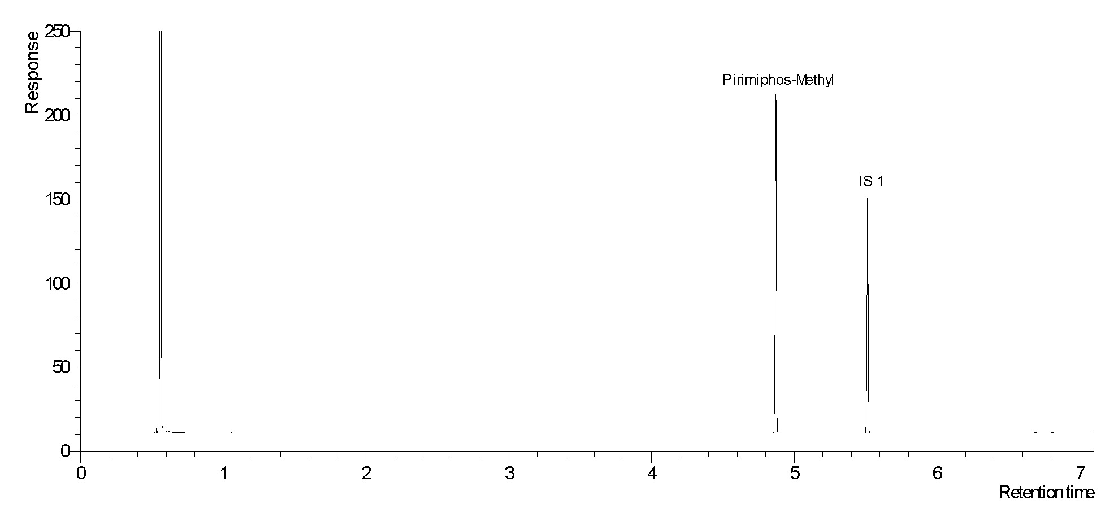

Fig .. Typical chromatogram of pirimiphos-methyl TC

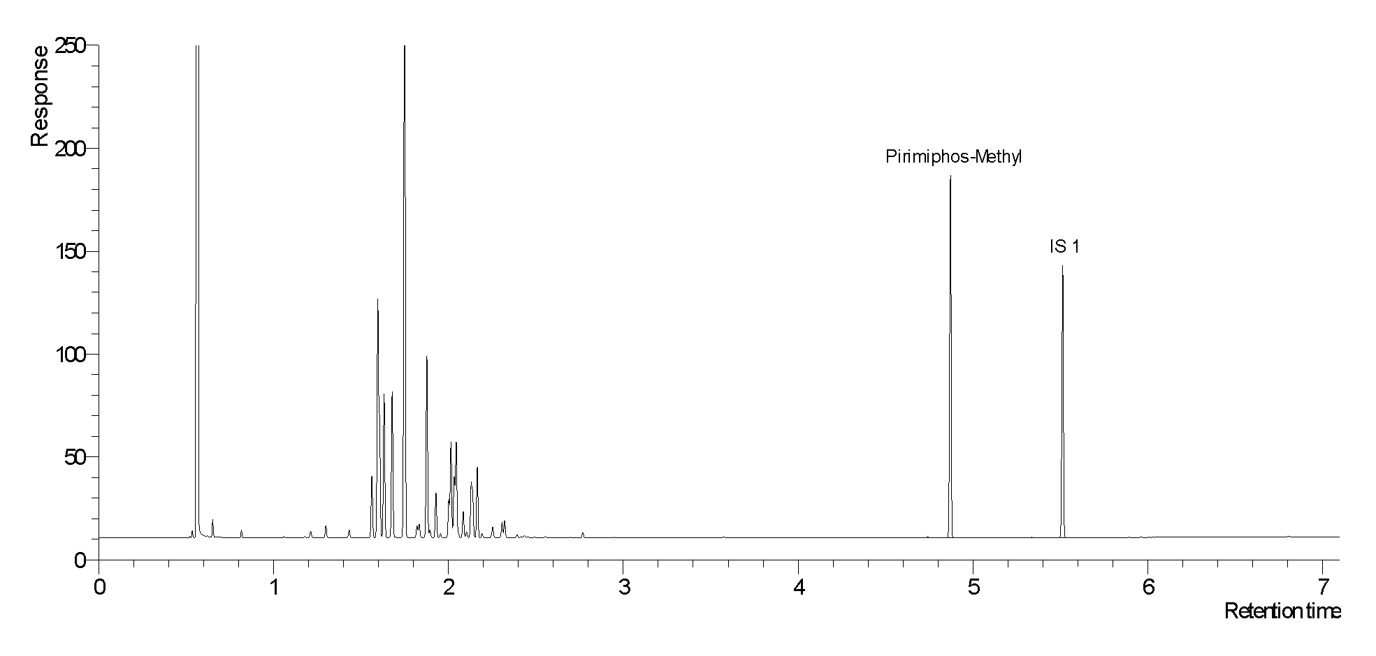
Fig .. Typical chromatogram of pirimiphos-methyl in EC

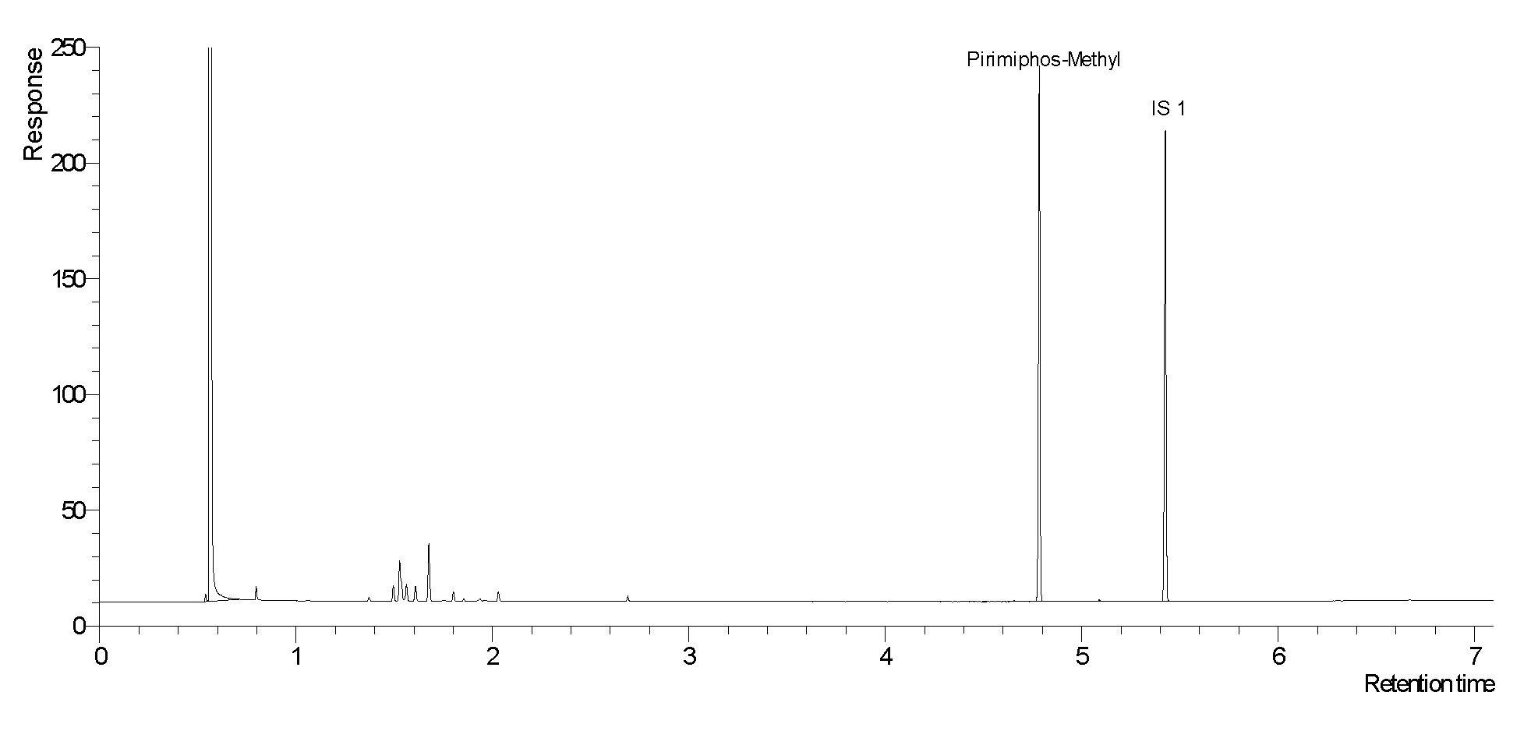
Fig .. Typical chromatogram of pirimiphos-methyl CS

Fig ..Chromatogram of pirimiphos-methyl and iso-pirimiphos-methyl in a CS formulation

Fig Chromatogram of relevant impurities DMPCT, MeOOOPS, MeOOSPO and MeOOSPS in pirimiphos-methyl CS with exclusion of the pirimiphos-methyl peak for a better visualisation of the impurities. Elution time of pirimiphos-methyl is 10.1 min

Fig .. Full MS spectrum of DMPCT

Fig .. Full MS spectrum of MeOOOPS

Fig .. Full MS spectrum of MeOOSPO

Fig .. Full MS spectrum of MeOOSPS

Fig .. Full MS spectrum of pirimiphos-methyl

Fig ..Full MS spectrum of iso-pirimiphos-methyl

Fig .. Full MS spectrum of 4,4-dimethoxybenzophenone

* CIPAC method 2012. Prepared by the Swiss committee. Based on a method supplied by Syngenta Crop Protection AG, Switzerland.
* CIPAC method 2012. Prepared by the Swiss committee. Based on a method supplied by Syngenta Crop Protection AG, Switzerland

